Create
1) Create two tables
Candidate (This table stores the different political candidates)
First name
Last Name
DOB Make it a date format
Salary

Party (This table contains the different political parties)
PartyDesc

You decide what the types are going to be. Do not put any constraints.
(NOTE: Column names cannot be two separate words. Use an underscore)
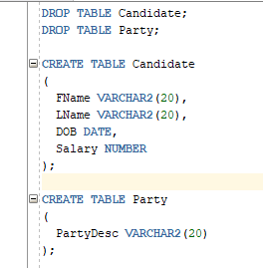

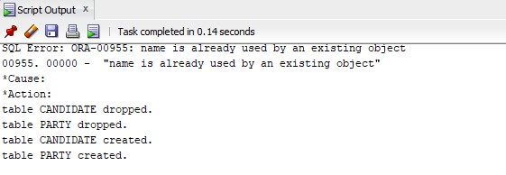

2) Using the alter table statement drop the DOB column
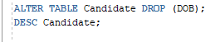

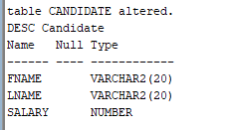
3) Using the alter table statement add the DOB column
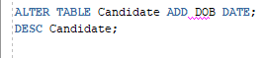

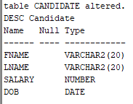
4) Using the alter table statement to add primary keys to both tables. (NOTE: You will have to add additional columns for the primary key)
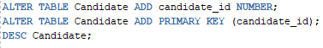

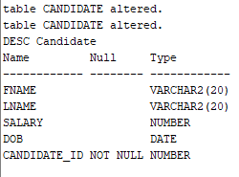

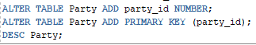

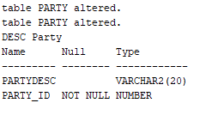
5) Using the alter table statement add a composite candidate key to the Candidate table. Pick whatever column(s) you want.
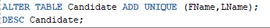

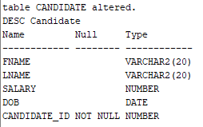
6) Drop the Party table. Recreate it with the primary key. (Do not use alter table. Just use the create table statement)
